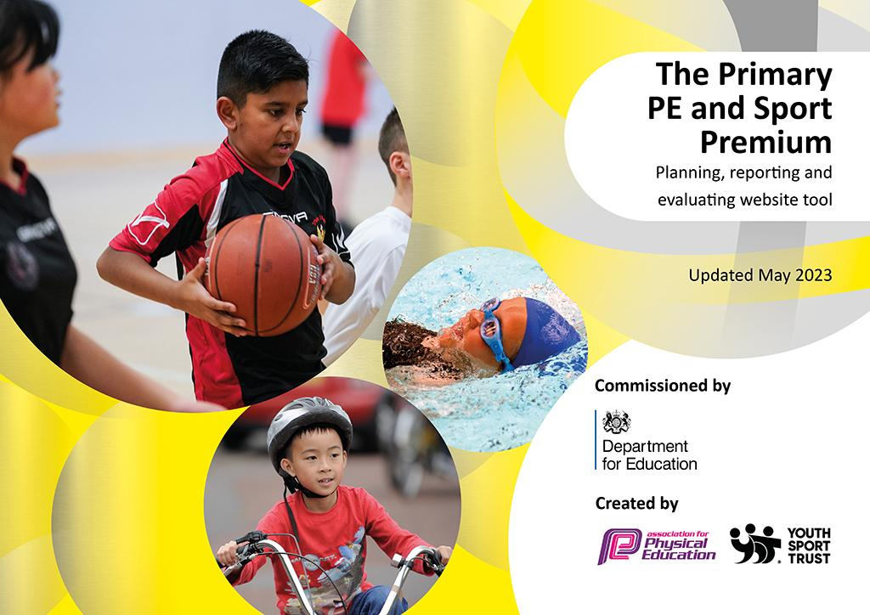
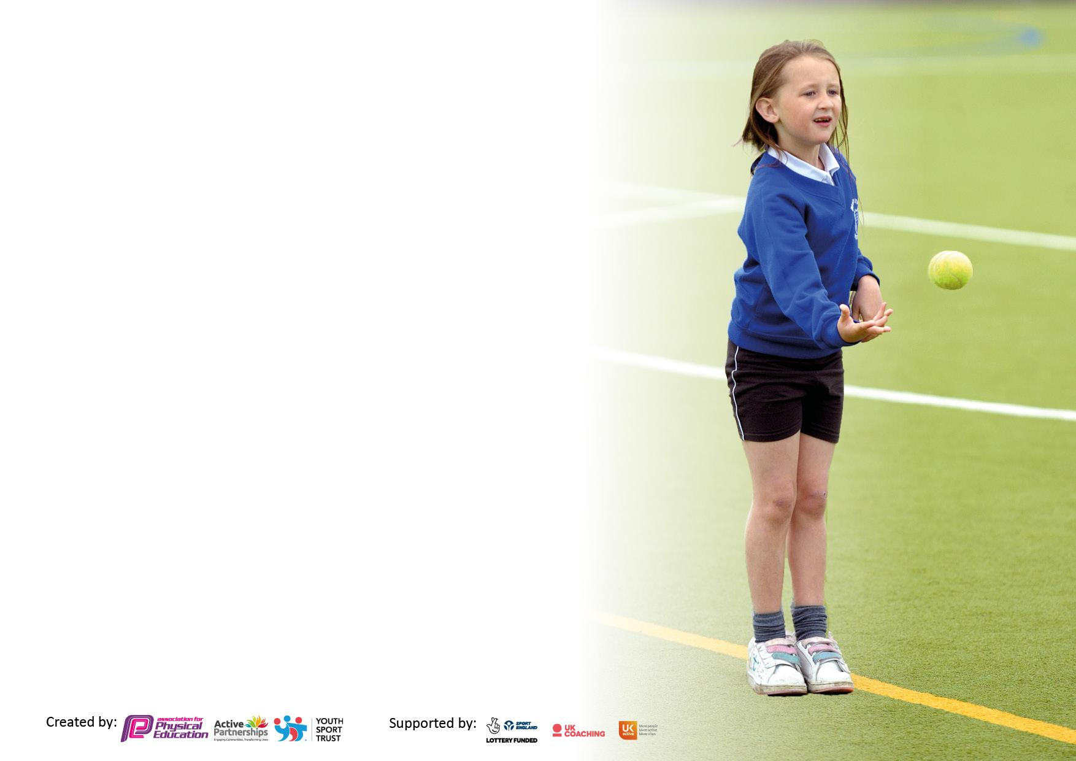
It is important that your grant is used effectively and based on school need. The Education Inspection Framework makes clear there will be a focus on ‘whether leaders and those responsible for governors all understand their respective roles and perform these in a way that enhances the effectiveness of the school’.

Under the Quality of Education Ofsted inspectors consider:
Intent - Curriculum design, coverage and appropriateness
Implementation - Curriculum delivery, Teaching (pedagogy) and Assessment
Impact - Attainment and progress

To assist schools with common transferable language this template has been developed to utilise the same three headings which should make your plans easily transferable between working documents.

Schools must use the funding to make additional and sustainable improvements to the quality of Physical Education, School Sport and Physical Activity (PESSPA) they offer. This means that you should use the Primary PE and sport premium to:

- Develop or add to the PESSPA activities that your school already offer
- Build capacity and capability within the school to ensure that improvements made now will benefit pupils joining the school in future years
- The Primary PE and sport premium should not be used to fund capital spend projects; the school’s budget should fund these.

Please visit gov.uk for the revised DfE guidance including the5keyindicatorsacrosswhichschoolsshoulddemonstrate an improvement. This document will helpyoutoreviewyourprovisionandtoreportyourspend.DfEencouragesschools to use this template as an effective way of meeting the reporting requirements of the Primary PE and Sport Premium.

We recommend you start by reflecting on the impact of current provision and reviewing the previous spend.

Schools are required to publish details of how they spend this funding, including any under-spend from 2021/2022, as well as on the impact it has on pupils’ PE and sport participation and attainment. The funding should be spent by 31st July but the DfE has stated that there will be no clawback of any unspent money so this can be carried forward into 2023/24.

We recommend regularly updating the table and publishing it on your website throughout the year. This evidences your ongoing self-evaluation of how you are using the funding to secure maximum, sustainable impact. Final copy must be posted on your website by the end of the academic year and no later than the 31st July 2023. To see an example of how to complete the table please click HERE.
Details with regard to funding
Please complete the table below.

Total amount allocated for 2021/22 | £19,110
How much (if any) do you intend to carry over from this total fund into 2022/23? | £6,132.32
Total amount allocated for 2022/23 | £19,920
Total amount of funding for 2022/23. Ideally should be spent and reported on by 31st July 2023. | £25,052.32
Swimming Data
Please report on your Swimming Data below.

Meeting national curriculum requirements for swimming and water safety.

N.B. Complete this section to your best ability. For example you might have practised safe self-rescue techniques on dry land which you can then transfer to the pool when school swimming restarts.
Due to exceptional circumstances priority should be given to ensuring that pupils can perform safe self rescue even if they do not fully meet the first two requirements of the NC programme of study
What percentage of your current Year 6 cohort swim competently, confidently and proficiently over a distance of at least 25 metres?  N.B. Even though your pupils may swim in another year please report on their attainment on leaving primary school at the end of the summer term 2023.  Please see note above | 96%
What percentage of your current Year 6 cohort use a range of strokes effectively [for example, front crawl, backstroke and breaststroke]?  Please see note above | 96%
What percentage of your current Year 6 cohort perform safe self-rescue in different water-based situations? | 70%
Schools can choose to use the Primary PE and sport premium to provide additional provision for swimming but this must be for activity over and above the national curriculum requirements. Have you used it in this way? | Yes/No

Action Plan and Budget Tracking
Capture your intended annual spend against the 5 key indicators. Clarify the success criteria and evidence of impact that you intend to measure to evaluate for pupils today and for the future.

Academic Year: 2022/23 | Total fund allocated: | Date Updated:
Key indicator 1: The engagement of all pupils in regular physical activity – Chief Medical Officers guidelines recommend that primary school pupils undertake at least 30 minutes of physical activity a day in school |  |  |  | Percentage of total allocation:
 |  |  |  | %
Intent | Implementation |  | Impact
Your school focus should be clear what you want the pupils to know and be able to do and about  what they need to learn and to  consolidate through practice: | Make sure your actions to achieve are linked to your intentions: | Funding allocated: | Evidence of impact: what do pupils now know and what can they now do? What has changed?: | Sustainability and suggested next steps:
Encourage active play and physical activity for KS1 and KS2 during playtimes and lunchtimes  To encourage the safe play for all year groups | Purchase of new playground equipment and implementation of playground leaders to facilitate active play  Purchase of safety barriers to allow facilitate safe play space for all year groups, especially during the winter months when the field becomes unsuitable | £1903.50 – Playground equipment  £1600 - barriers/ dividers |  | Continue to monitor children’s active playtimes and the equipment. Act on children’s requests and preferences to ensure there is sufficient equipment to engage children and keep them active  Monitor the effectiveness of barriers and how these can be used elsewhere to maintain participation in a safe manner
Key indicator 2: The profile of PESSPA being raised across the school as a tool for whole school improvement |  |  |  | Percentage of total allocation:
 |  |  |  | %
Intent | Implementation |  | Impact
Your school focus should be clear what you want the pupils to know and be able to do and about  what they need to learn and to  consolidate through practice: | Make sure your actions to achieve are linked to your intentions: | Funding allocated: | Evidence of impact: what do pupils now know and what can they now do? What has changed?: | Sustainability and suggested next steps:
Qualified dance teacher to be able to deliver high quality dance lessons to all children  Qualified dance teacher to teach cross curricular dance for events through the year  To purchase a sports storage unit to maintain the longevity of the equipment and to instil a pride in the children over their equipment | Dance teacher to deliver PE lessons with class teachers on hand to assist and take on ideas and skills to be able to use in the future  All children to participate in the extra dance related to events through the year  Sports captains/ playground leaders to be responsible for the setting up and putting away of the sports equipment at each lunchtime | £2730 – Dance teacher  £140  £710 |  | Continue to use the dance coach to deliver the dance part of the curriculum.  Continue to participate in specialised events throughout the year when relevant to big events and tournaments to raise the profile of physical activity and sport e.g. 2022 World Cup  Storage unit to last many years and allow for the preservation of equipment

Key indicator 3: Increased confidence, knowledge and skills of all staff in teaching PE and sport |  |  |  | Percentage of total allocation:
 |  |  |  | %
Intent | Implementation |  | Impact
Your school focus should be clear | Make sure your actions to | Funding | Evidence of impact: what do | Sustainability and suggested
what you want the pupils to know | achieve are linked to your | allocated: | pupils now know and what | next steps:
and be able to do and about | intentions: |  | can they now do? What has
what they need to learn and to |  |  | changed?:
consolidate through practice:
Use of cricket coaching company  New Equipment | Cricket coach to come in and work alongside teachers to deliver high quality PE lessons. Allow for upskilling of teachers to work alongside cricket coach and take on ideas for future delivery  Reordering a range of new PE and Sport equipment to ensure the children have the highest provision when undertaking lessons taught by both PE Coach and Class Teacher  Football Goal and nets | £2196.50 – Cricket coach  £4000  £2521 |  | Training courses for PE coach and subject lead to be able to network and develop understanding to better develop the implementation of the PE curriculum  Use of new storage unit and PE shed existing to ensure the longevity of equipment
Key indicator 4: Broader experience of a range of sports and activities offered to all pupils |  |  |  | Percentage of total allocation:
Intent | Implementation |  | Impact
Your school focus should be clear | Make sure your actions to | Funding | Evidence of impact: what do | Sustainability and suggested
what you want the pupils to know | achieve are linked to your | allocated: | pupils now know and what | next steps:
and be able to do and about | intentions: |  | can they now do? What has
what they need to learn and to |  |  | changed?:
consolidate through practice:
Try a new sport - increase participation and open experiences for children  Orienteering Package | New equipment of new sports such as to introduce children to new sports  Give children a broader experience of part of the curriculum currently lacking | £1000.00  £2000 |  | See how children respond to new sports. Hope to develop school sport links to be able to compete against other schools and for children to develop an interest to follow up with outside school agencies  Children able to explore new interests using different equipment and style of activity

Key indicator 5: Increased participation in competitive sport |  |  |  | Percentage of total allocation:
 |  |  |  | %
Intent | Implementation |  | Impact
Your school focus should be clear | Make sure your actions to | Funding | Evidence of impact: what do | Sustainability and suggested
what you want the pupils to know | achieve are linked to your | allocated: | pupils now know and what | next steps:
and be able to do and about | intentions: |  | can they now do? What has
what they need to learn and to |  |  | changed?:
consolidate through practice:
To order new sports equipment that will allow the school to participate in home football matches, along with a new football kit to be worn in competitive matches.  Participate in CAFC football tournament as last few years  Children to participate in intra-house sporting competitions to raise the profile of house captains and house colour teams as well as annual sports day  To continue to participate in Bexley swim galas  Trophies and rewards to be given in end of Year 6 leavers for outstanding contribution | To continue to develop school links with local schools to participate in inter-school matches and competitions in a range of sports/ physical activity  To continue to participate in events with a high level of respect and sportsmanship.  Year 6 children having the opportunity to participate in swimming competitions against local schools  To celebrate high achievers and to recognise their contributions | £470– equipment  £41.50 – Sports day stickers/ equipment |  | Ensure equipment is looked after and respected by all children and any after school clubs that use this. Begin to build on developing school sport engagement year on year with the upcoming Year 6’s each year aiming to emulate previous years.  Develop a routine of children participating in intra-house sports competitions at different stages throughout the year

Signed off by
Head Teacher: | Oliver Winstone
Date:
Subject Leader: | Charlie Nutting
Date:
Governor:
Date:

